|  |  |
| --- | --- |
| User Manual  Invoke-MSLatestUpdateDownload - GUI |  |
|  | V2.0.0  April 2020 |

**USER MANUAL**

Content

About Application. 4

What can you do with it? 5

System Requirements for PowerShell. 6

Installation. 7

Get started. 8

# About Application.

A Graphical User Interface for the existent Invoke-MSLatestUpdateDownload script using PowerShell as the programming language.

It pretends to be simple, intuitive and useful at the same time.

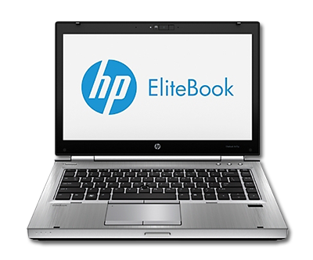

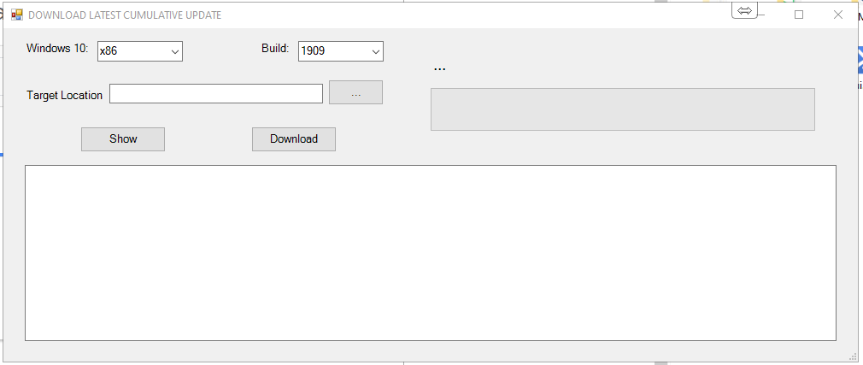

# What can you do with it?

This GUI only lets the user ask for Windows 10 x86 and x64 architecture within 1909, 1903 and 1809 build versions.

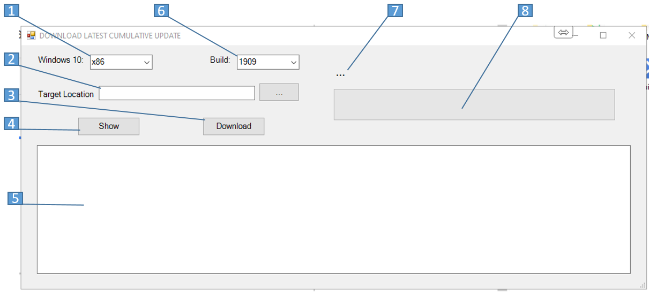

1. Architecture selector: Specify the operating system architecture, either x64-based or x86-based.
2. Specify the path where the updates will be downloaded.
3. Ask the software to start the download
4. Ask the software to show the last available updates
5. Output process results
6. Build selector: Specify a single operating system build versions, e.g. 1803, 1809 or 1903.
7. The status label that displays percent of download
8. Progress bar for the download process.

# System Requirements for PowerShell.

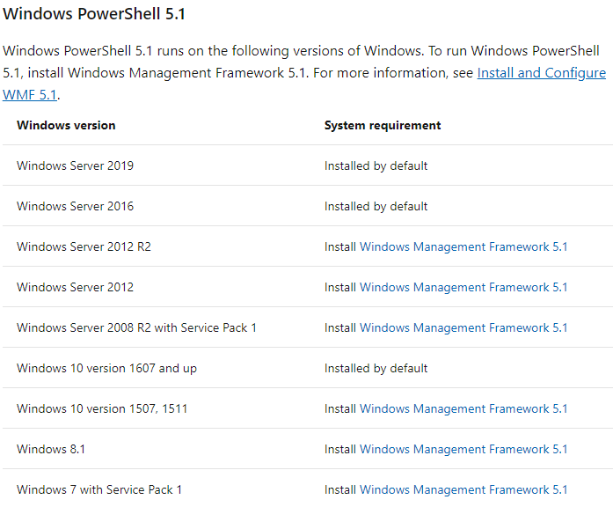

# Installation.

Copy the Invoke-MSLatestUpdateDownload-GUI.PS1 or Invoke-MSLatestUpdateDownload-GUI.Exe file in the folder of your preference.

The GUI can run almost everywhere.

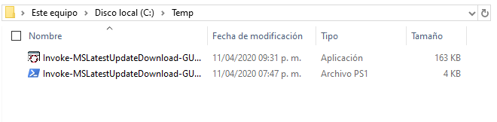

# Get started.

1.- Open the Invoke-MSLatestUpdateDownload-GUI.PS1 or the Invoke-MSLatestUpdateDownload-GUI.Exe file:

2.- When the software starts you will notice that the default folder path set is where the script is located.

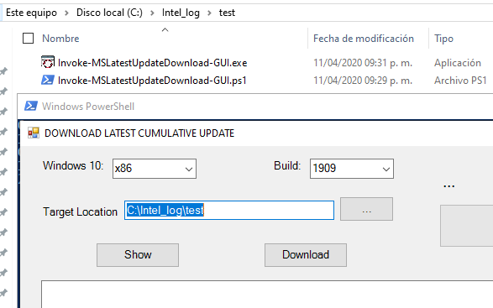

3.- Set the parameters as you need for your query.

4.- Click the “Show” button to ask only for the last update available.   
*Note: You do not need to set a path destination for this action, so you even can set the path as blank. 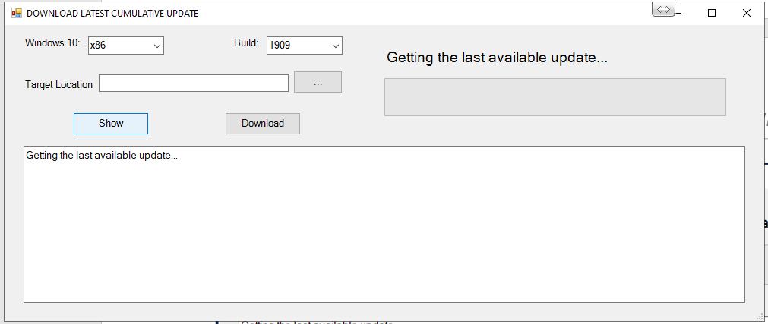

5.- When the process is finished you can see the results in the output textbox process

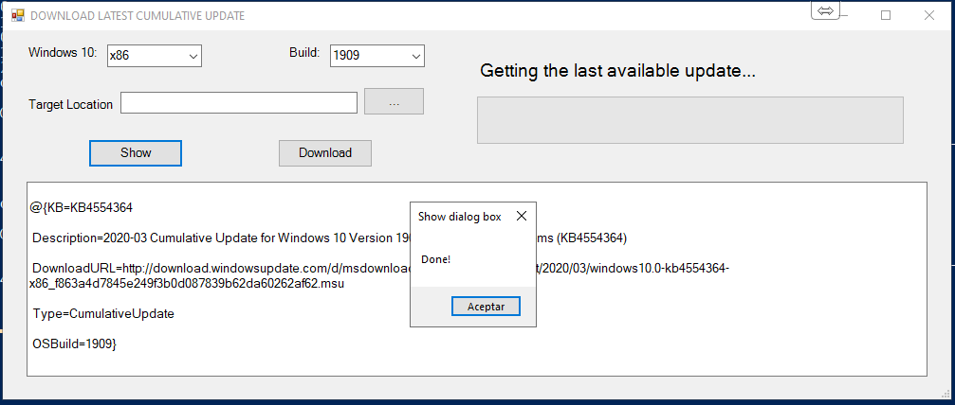

6.- Click on the “Accept” button to continue.

7.- Click the “…” button in the “Target Location” section to set the path folder destination for the download.

8.- You will see a folder path selector where you can choose the one you prefer.

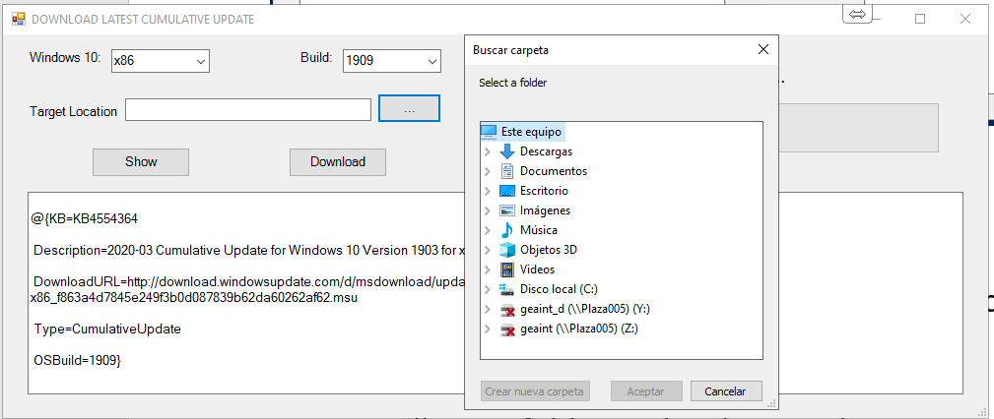

9.- Clock on the “Download” button to start the download process.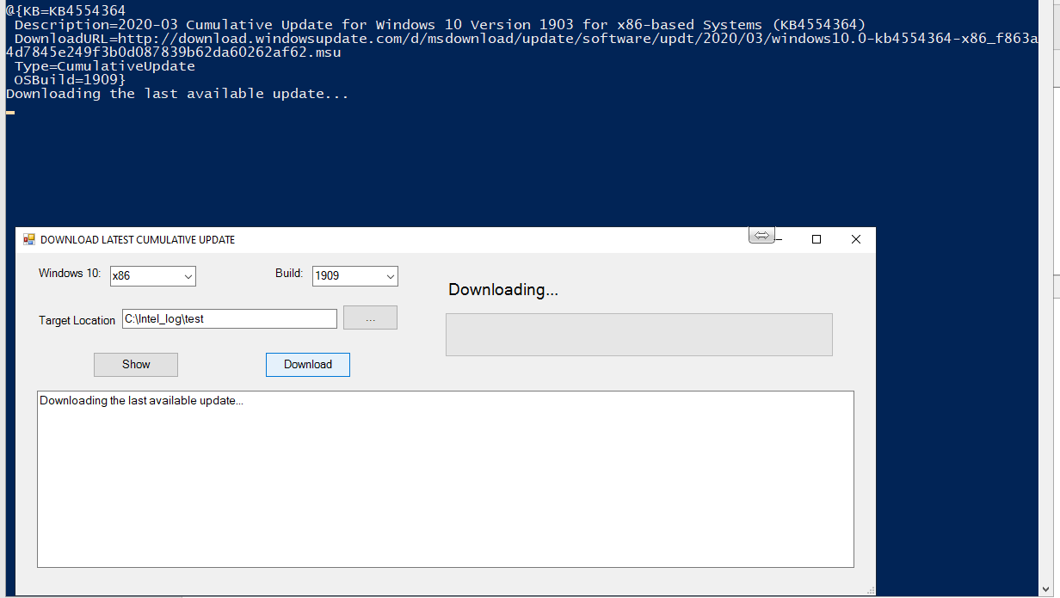

10.- You can see the current percent downloaded value in the progress bar.

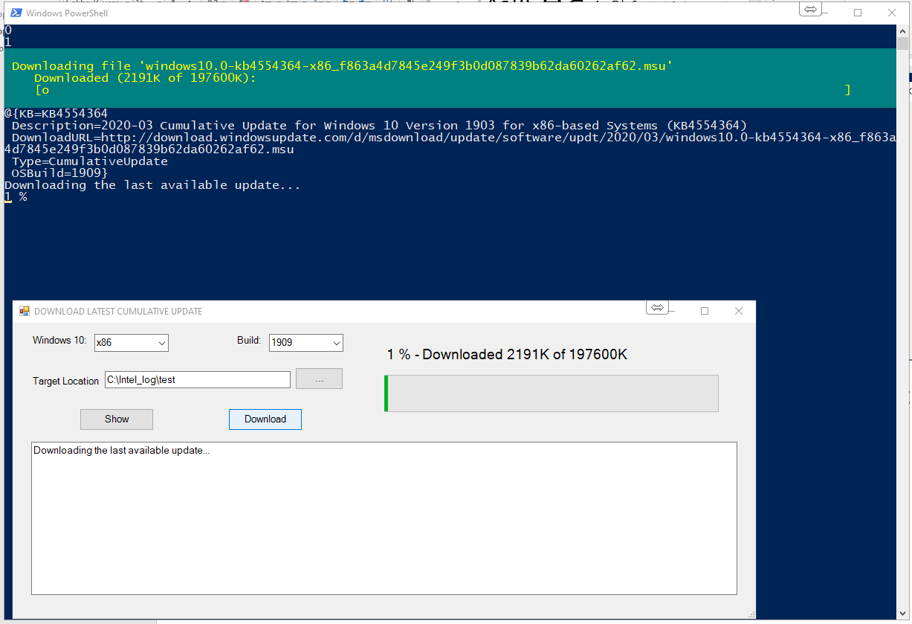

10.- When the process is done, click on “Accept”

11.- You can do Show/download queries as you need.